QUWF Tractor Safety Bulletin – Tractor Roll Over/Flip Over
With so many getting into hobby farming, buying tractors for wildlife habitat work or putting in food plots, all should know the danger areas of tractor operation.
The number one cause of death on a tractor is roll over. Tractors are fun to operate but like any machine, from a lawn mower to a jet aircraft, you have to know the limitations and operating envelopes they perform best in. Then too, you must know the danger zones where you should not be operating the tractor.
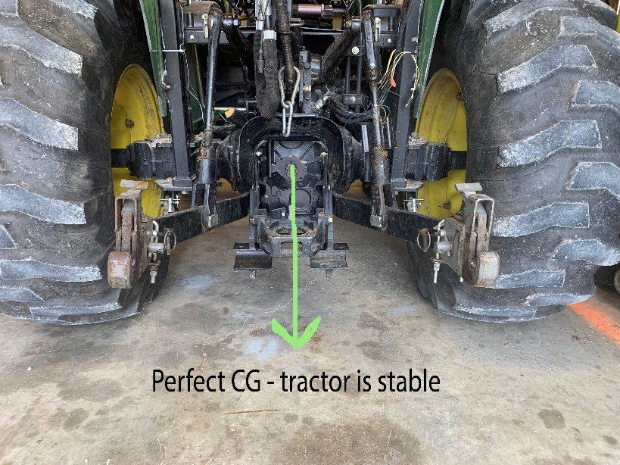
The tractor has a central center of gravity (CG), all equipment does, that point when stable is a 90-degree angle to the ground. Think of it like putting a carpenter’s square on the ground or a plumb bob and drawing a line to the stable center of mass of the equipment. On tractors, that point normally is the power take off shaft.
NOTE: the CG can be higher if you have a large cab or tractor which makes your approach to the CAUTION LINE faster.
When on flat ground you are in perfect CG conditions and the equipment and the attachments are stable (photo at left).
As you traverse side hills the angle of the CG changes, increasing the potential for rollover.
Imagine that CG line as a plumb bob swinging from the PTO shaft, as you tilt the tractor in either direction, the plumb bob heads towards the edge of the tire.
As the imaginary plumb bob line hits the inside edge of the tire that is your CAUTION LINE. Proceeding to a greater angle across the tire’s width, increases the potential for rollover quickly (photo below right).
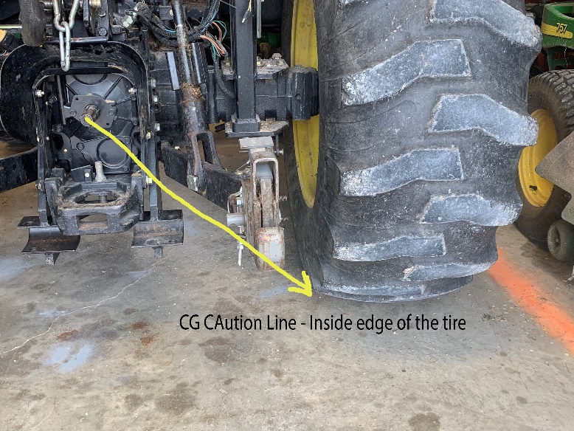
If you tilt the tractor to the point the imaginary CG line hits the outside edge of the tire, the DANGER LINE, roll over will occur and so fast you will not consciously know it happened.
No one, even the most experienced operators, can properly “feel” the danger line angle so you must understand it exists and ere to the side of caution and avoid that uneasy feeling of a tilted tractor.
As you continue the tilt and the imaginary plumb bob increases the angle within the tire area, rollover is imminent. Why? You cannot see hidden rocks or ground features that suddenly increase the tilt on the tractor to the roll over point and rollover occurs quickly, without warning!!
Note the photo below and how increasing the tilt line through the tire increases roll over potential very quickly to the point of no return, the DANGER LINE.
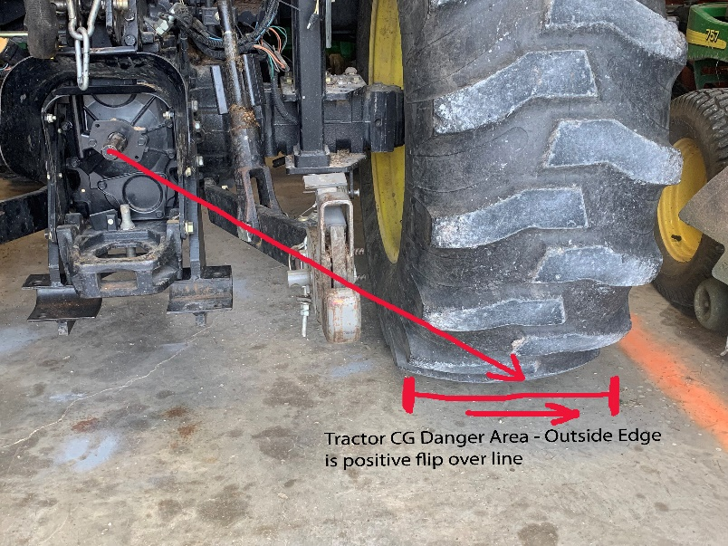
If you feel it start and are uncomfortable with the angle, turn down hill to decrease the angle and stabilize the CG again. Stay off hills that are too steep.
This also speaks to the ABSOLUTE need for the ROPS (roll over protection system) on modern tractors. They are installed because rollover IS the number one cause of death on tractors.
The ROPS bars are designed to protect the operator from being crushed BUT, and this is a big BUT, you must be wearing your seat belt so you are not thrown from the tractor and rolled on. I know it is hard to get into the habitat of wearing a seat belt on a tractor because you jump on and off so much. However, on hilly terrain with a tilt factor, that is not the case. WEAR IT.

So now what else can you do to lessen the rollover CG danger on a tractor and give yourself (and your family) every advantage possible?
- Always have the ROPS installed and up
- Always wear a seat belt, especially on any side hill
- Have your wheels “turned out” on your tractor, front and back, so you have the widest distance between them possible. This gives you more angle in the safe zone. Your dealer can do it since filled tires are very heavy but have it done
- Make sure your tires are inflated properly, both sides being equal. Wide rear tires have more stability than narrow tires.
- Dual rear wheels do increase the stability footprint but most of us will not need dual rear tires in the work we do

Tractor flip over, front to back is another danger;
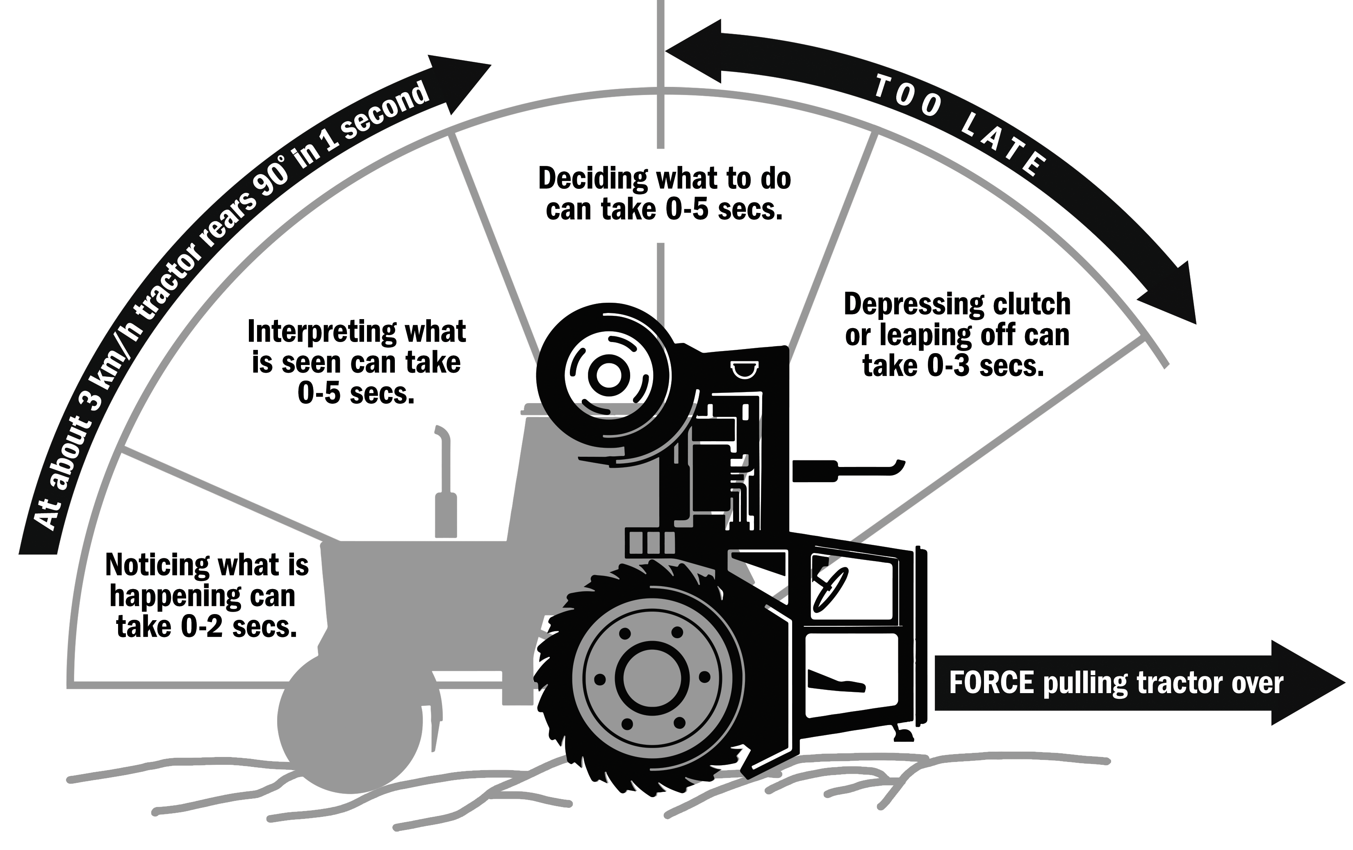
The chart below shows the reaction time to a flip over. This can be especially important if you have an older tractor like a FORD 8N that is known for its ability to pull hard and flip over fast. The FORD N series has no factory ROPS system so be extra cautious when pulling heavy items because you may not notice the front of the tractor is off the ground several feet.
Notice the chart states a tractor can go 90 degrees in 1 second at 1.8 MPH.

Operating a tractor is fun and one of the basic enjoyments of wildlife and farm work. Using it for food plots for deer, turkey, dove, clearing land, bush hogging access and egress roads or reclaiming pastures are all fun. Know its limitations and operating envelope, keep yourself and your family safe.

Author- Craig Alderman-QUWF
calderman@quw.net
©2021 QUWF, All Rights Reserved.

