QUWF Research Information 11/24/21

Per- and Polyfluoroalkyl Substances (PFAS)
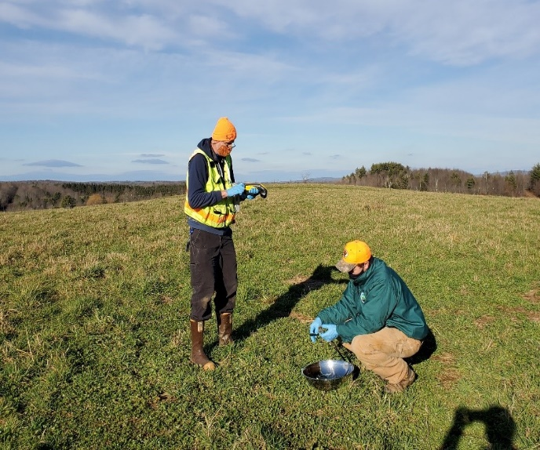
PFAS refer to a group of man-made chemicals known as Per- and Polyfluoroalkyl Substances. There are thousands of varieties of these chemicals including the six PFAS chemicals which are included in, Resolve 2021, Chapter 82 (Resolve, To Protect Consumers of Public Drinking Water by Establishing Maximum Contaminant Levels for Certain Substances and Contaminants) and listed below:
- Perfluorooctanoic acid (PFOA)
- Perfluorooctanesulfonate (PFOS)
- Perfluorononanoic acid (PFNA)
- Perfluorohexanesulfonic acid (PFxHS)
- Perfluoroheptanoic acid (PFHpA)
- Perfluorodecanoic acid (PFDA)
As early as the 1940's, PFAS (mostly PFOA and PFOS earlier on) became widely used in household products and industrial settings. These chemicals were also historically used in firefighting foams due to their effectiveness at quickly extinguishing petroleum-based fires. Because they have a unique ability to repel oil, grease, water and heat, PFAS are used in many common products that we use regularly. For example, they have been used to make non-stick cookware, stain-resistant carpets and furniture, water-resistant clothing, heat-resistant paper/cardboard food packaging (like microwave popcorn and pizza boxes), and some personal care products. PFAS break down very slowly and are persistent in the environment. This means that PFAS may build up in people, animals, and the environment over time. Health agencies are working to understand more about the health effects of low level, long-term exposure.
Potential Health Impacts from PFAS
Decreases in fertility or increases in high blood pressure in pregnant women
Reduced ability of the body’s immune system to fight infections including reduced vaccine response
Child development effects including low birth weight, accelerated puberty, bone variations, or behavioral changes
Increased risk of some cancers including prostate, kidney, and testicular cancers
Interference with the body’s natural hormones
Increased cholesterol levels and/or risk of obesity

