Doyle Log Scale: How To Determine Board Feet In A Log

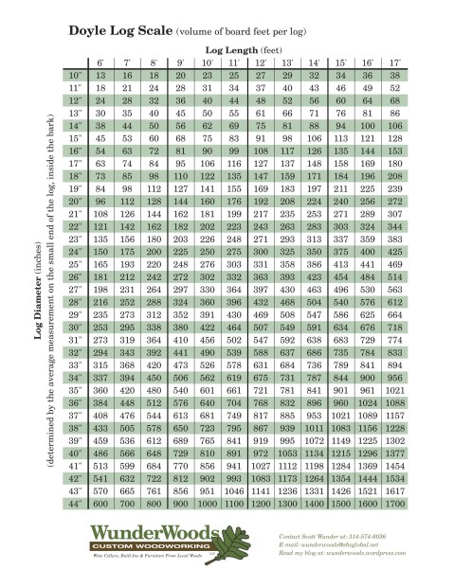
(Click this image for a larger view. Click the pdf link below for a printable Doyle log scale or Doyle log rule.)
Doyle Log Scale WunderWoods pdf
Many times customers will call to discuss having a log milled and how much it will cost. The answer is often based on how many board feet (12″ x 12″ x1″) will be produced. So, the first thing I ask is, “How big is the log?” Usually the answer is, “Well, I can’t get my arms around it.” And, while this may be helpful, there is a more accurate way to determine the size of a log and how many board feet will be produced.
There are three common scales or rules used in the industry (Doyle, Scribner, and International), but the Doyle scale is the most commonly used around the St. Louis area. All three of the scales estimate logs closely in the medium to larger size range, but the Doyle underestimates footage on the smaller logs. Because of this, it is advantageous for buyers of logs to use the Doyle scale to make up for extra log handling on small logs. Since the buyers like this scale, it is what they use and therefore, what the sellers use.
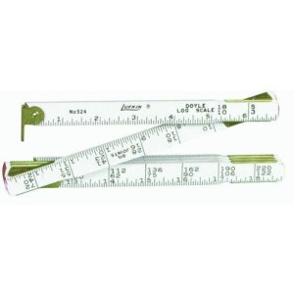
Doyle folding log rule used by most log buyers in Midwest
All buyers have a Doyle scale on them at all times, usually in the form of a folding rule with the footage marked at each inch. The printable version above has more increments on it, but it is basically the same and is used in conjunction with a tape measure. I always have a tape measure on me, so I usually use the printed version (they are also cheaper).
The formula for the scale is based on a tapered cylinder, milled with a 1/4″ kerf. Straight logs, with little taper and cut on a thin-kerf bandsaw will yield more lumber than the scale predicts. It usually averages out, because logs are usually not so perfect, and often have boards that are below-grade and end up in the firewood pile.
To use the scale, first measure the average diameter of the small end of the log inside the bark (in inches). Locate that row on the scale. Next, measure the length of the log (in feet). Move over on the scale to that length column. Where those two measurements intersect, you will find the board footage for that log. The process must be repeated for each log. Deductions are made for defects, like rot and curved logs.
Since sawmills usually charge by the board foot, this scale will help you determine the amount of lumber you will have and what you can expect your bill to be. Make sure to accurately measure your log and not just guess the diameter. The logs seem bigger than the actual measurement. My customers are usually off by about a foot in diameter on good-sized logs when they guess.
A little perspective on log sizes:
• A respectable diameter on a hardwood tree is 20″.
• A large diameter on a hardwood tree is 30+”.
• The smallest diameter most hardwood mills buy is 13″.
• The largest logs I get on a once-a-year basis is about 45″ diameter (8′-10′ from the ground).
• The largest hardwood I have ever milled is a 54″ diameter (20′ from the ground) Burr Oak.

